**Report: Armand Kruger (ST10473808)**

This is an easy-to-understand quiz game where you select true or false for a set question about history. The game consists out of 5 questions. When the user finished all 5 questions a score will be displayed out of 5. The user will have the option to review the questions with the correct answers as well as the option to restart the quiz game or to quit the game, which closes the application.

Link to YouTube video: https://youtu.be/kcn4Fjf7YSc

Link to GitHub: https://github.com/ST10473808/imad-ass2-st10473808/tree/master

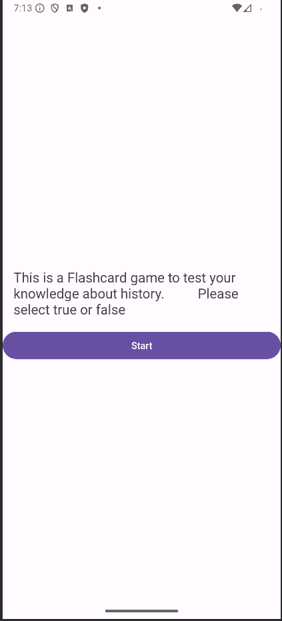

This is the Start screen which the user will see when they open the application.

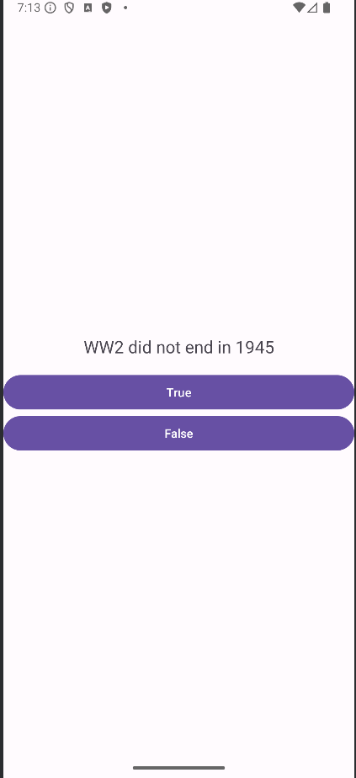

This is the questions screen the user will see after they pressed start.

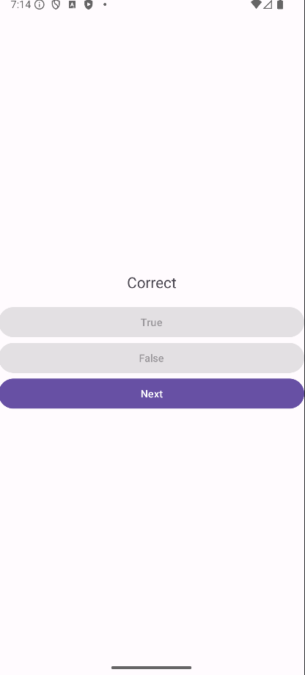

After the user chooses true or false for a question, they will get a response saying Correct or Wrong.

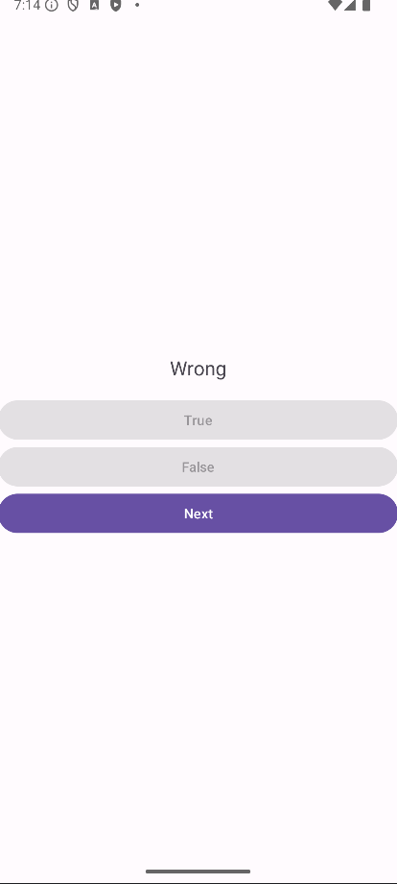

After the user selected true or false for a question, they can press the next button to go to the next question.



After the user completed the quiz game they will be given a score out of 5. With 3 options, review the questions with the answers, restart the Quiz or quit, which closes the application.

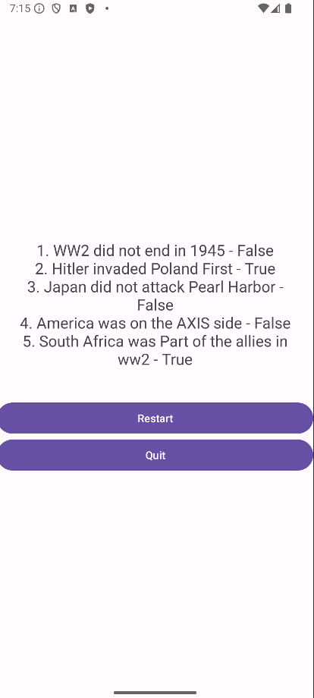

This is the screen the user will see after they press review.

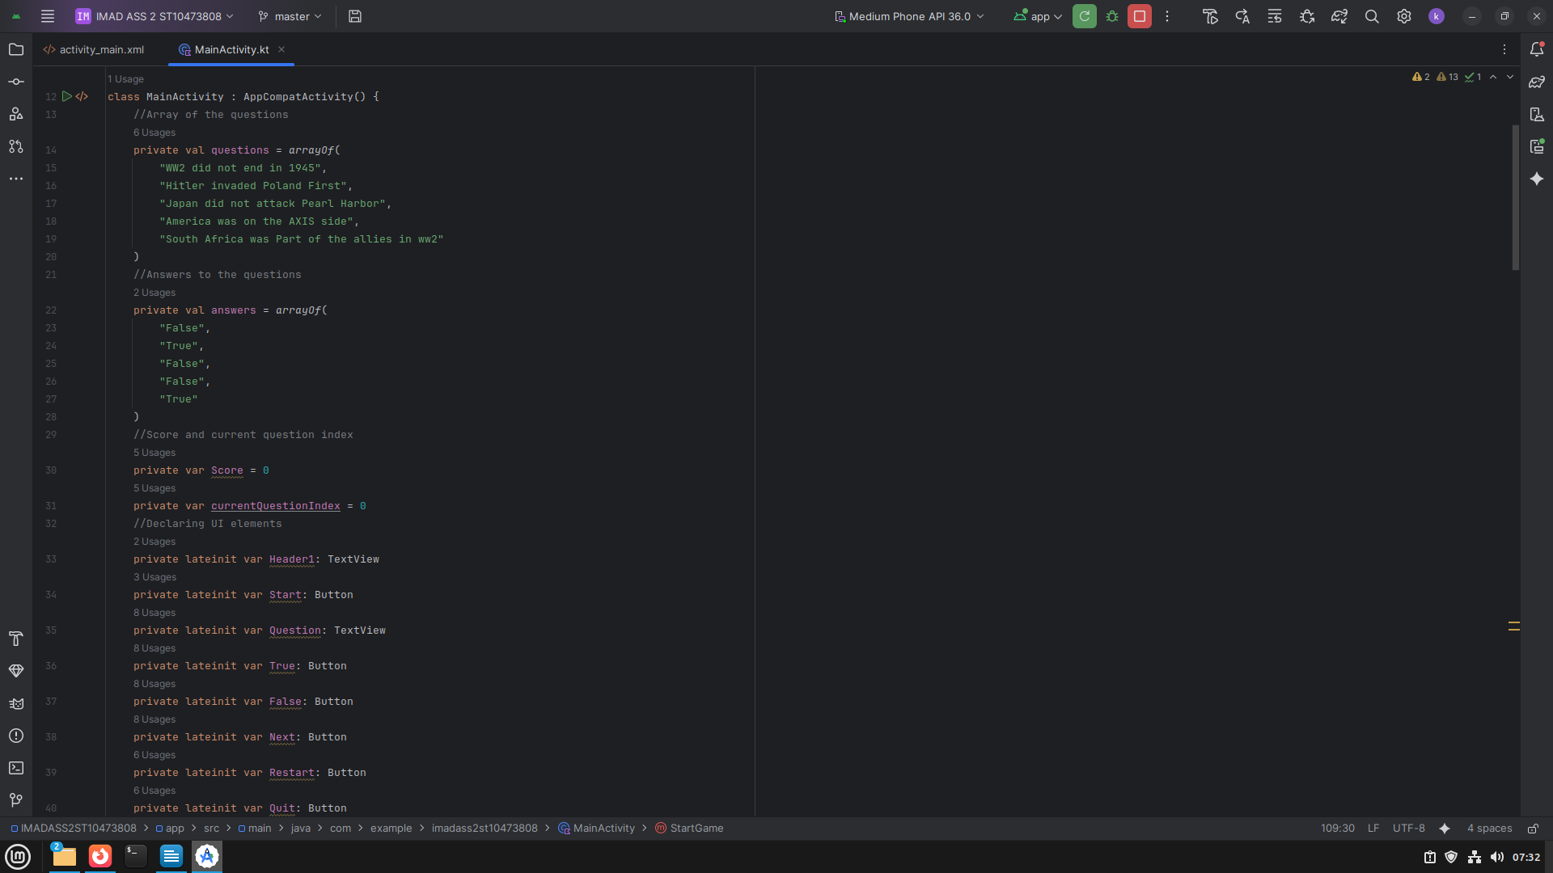

This is the code which declares our parallel array and the code which is responisble for the coding elements in the main activity file which we designed in the xml file.

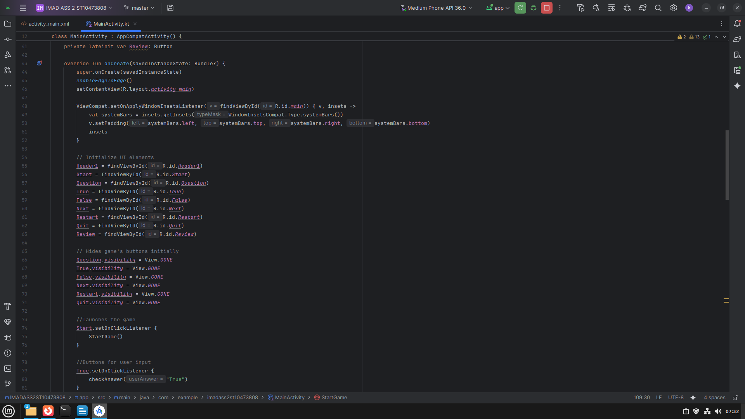

This is the code that mainly finds all the ui elements which allows us to handle what happens in the application.

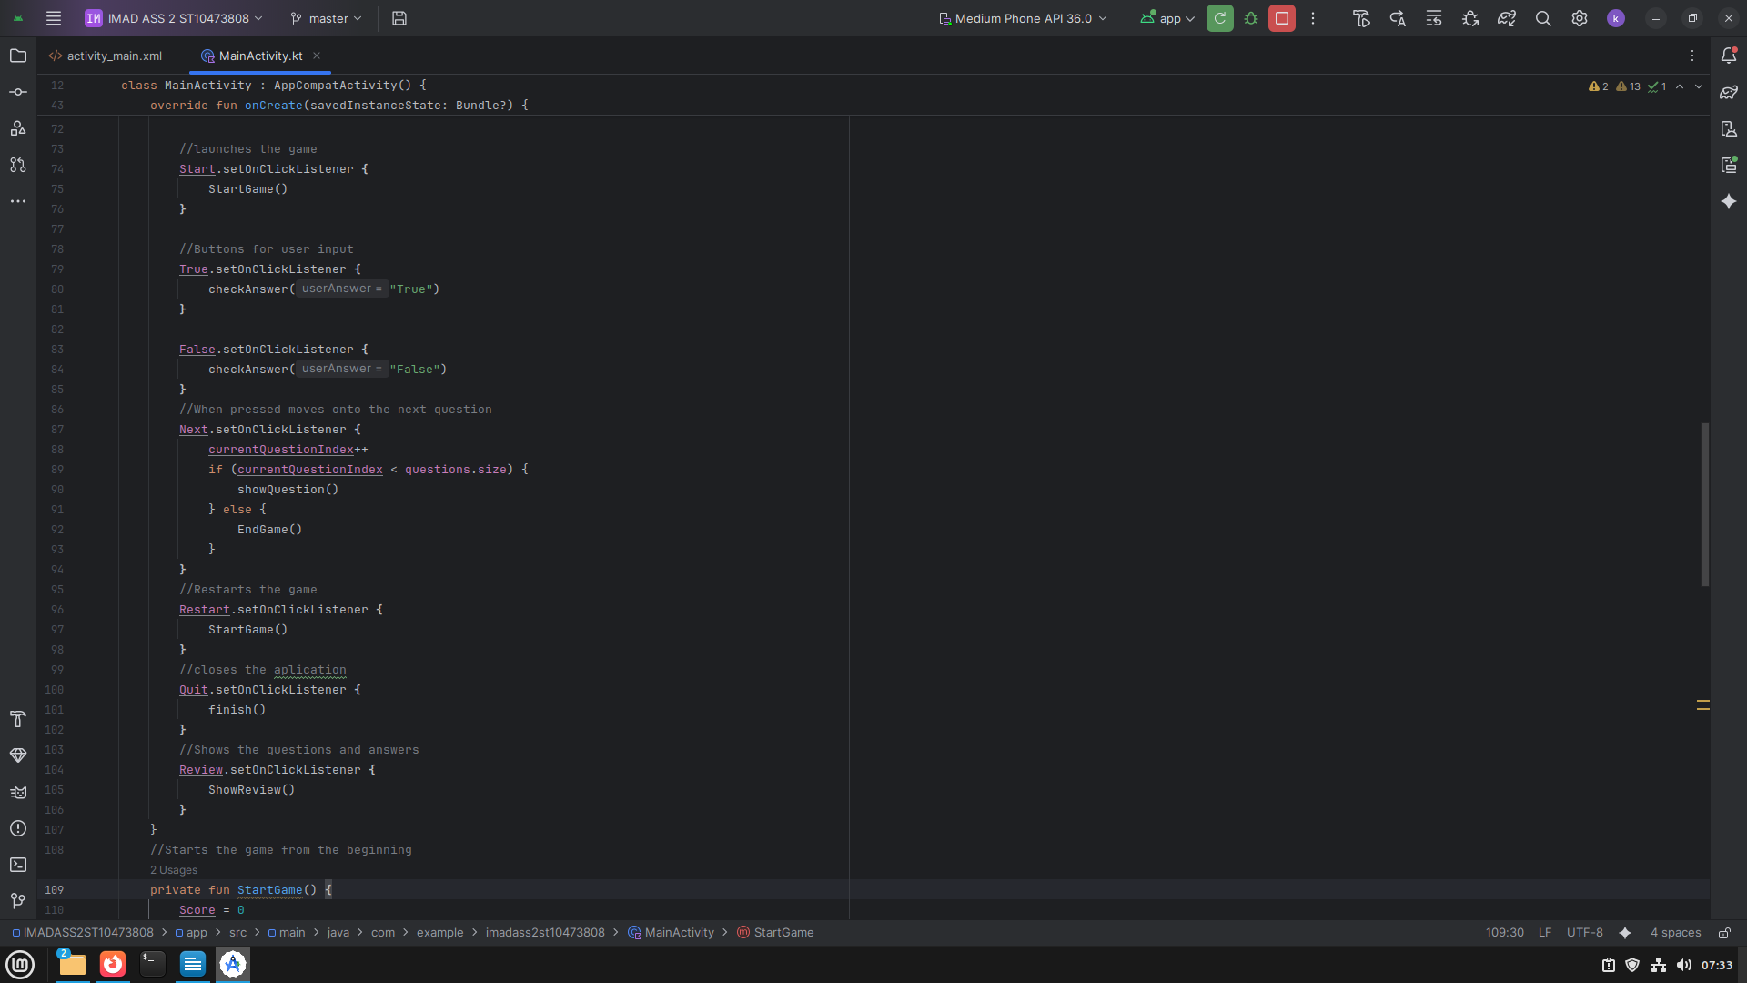

This is the code that deals with the application's main function. It contains the looping of the qustions, the Ui elements used to make the butttons work properly and that the questions display properly.

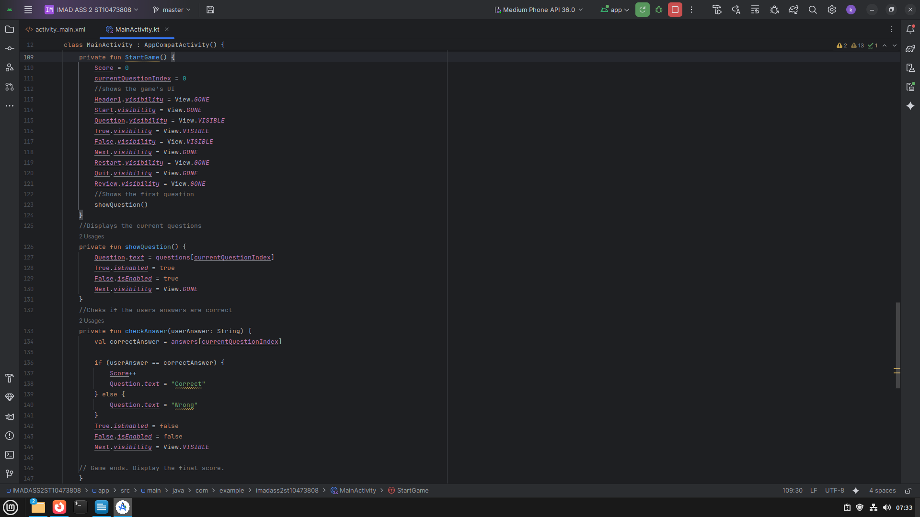

This is the code that is used to display the score at the end of the quiz.

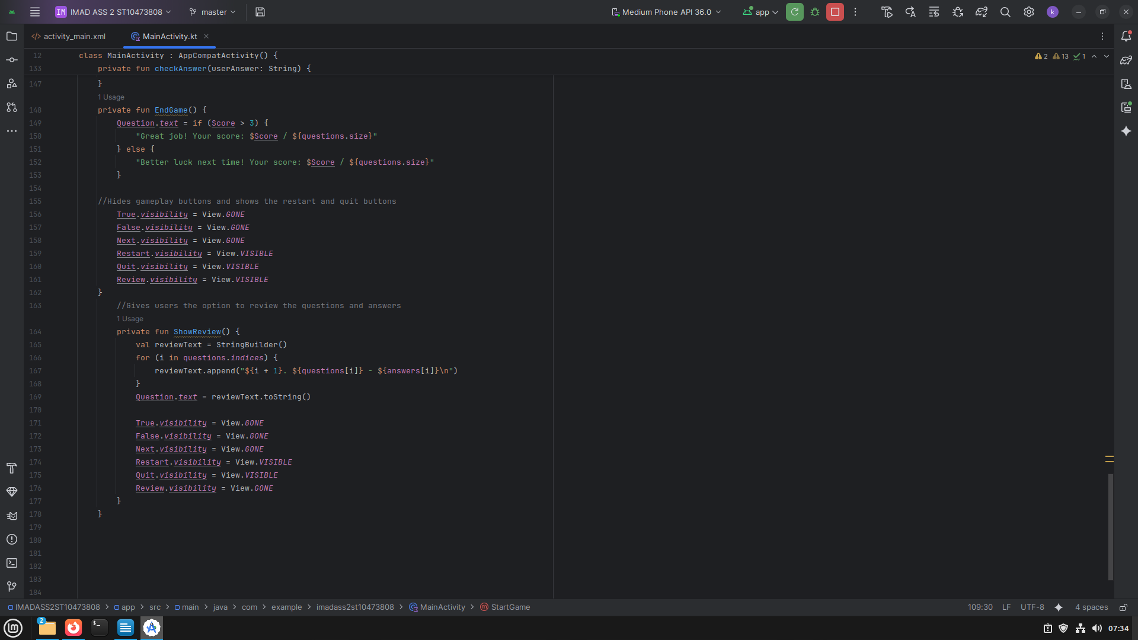

This is the code so that the user can view the questions with the correct answers when they press the review button.

Code references:  
 Bulbulia, Z.(2025)

<https://github.com/zb662000/assignmen>